DS LAB 1 (21K-4827)

Q.1)

#include <iostream>

using namespace std;

int main(int argc, char\* argv[])

{

cout << "You have entered " << argc << " arguments:" << "\n";

for (int i = 0; i < argc; ++i)

cout << argv[i] << "\n";

return 0;

}

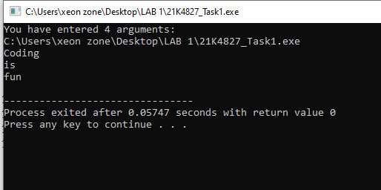

Q.2)

#include<iostream>

#include<fstream>

using namespace std;

int main (int argc,char\*\* argv) {

ofstream file;

file.open (argv[1]);

file << "Coding is fun.\n";

file.close();

ifstream file1;

string a,b,c;

file1.open (argv[1]);

file1>>a>>b>>c;

cout<<a<<" "<<b<<" "<<c<<" ";

file1.close();

ofstream file2;

file2.open (argv[2]);

file2 <<a<<" "<<b<<" "<<c<<" ";

file2.close();

return 0;

}

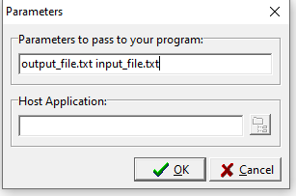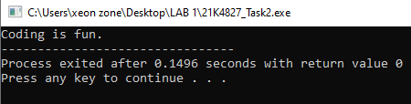

Q.3)

#include<iostream>

using namespace std;

int main () {

int num,sum;

do{

cout<<"Enter number: ";

cin>>num;

if(num<-1){

cout<<"Enter number greater than 0\n";

continue;

}

sum=0;

cout << "Factors of " << num << " are: ";

for(int i = 1; i <= num; ++i) {

if(num % i == 0){

sum+=i;

cout << i << " ";

}

}

cout<<"\nSum: "<<sum<<endl;

}while(num!=-1);

return 0;

}

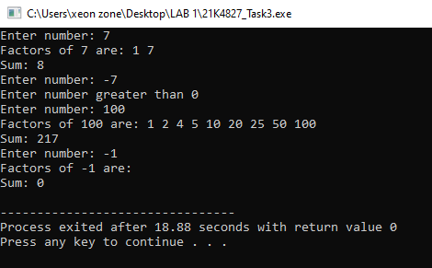

Q.4)

#include<iostream>

using namespace std;

int main () {

int num,sum;

do{

cout<<"Enter number: ";

cin>>num;

if(num<-1){

cout<<"Enter number greater than 0\n";

continue;

}

sum=0;

cout << "Factors of " << num << " are: ";

for(int i = 1; i <= num; ++i) {

if(num % i == 0){

sum+=i;

cout << i << " ";

}

}

cout<<"\nSum: "<<sum<<endl;

}while(num!=-1);

return 0;

}

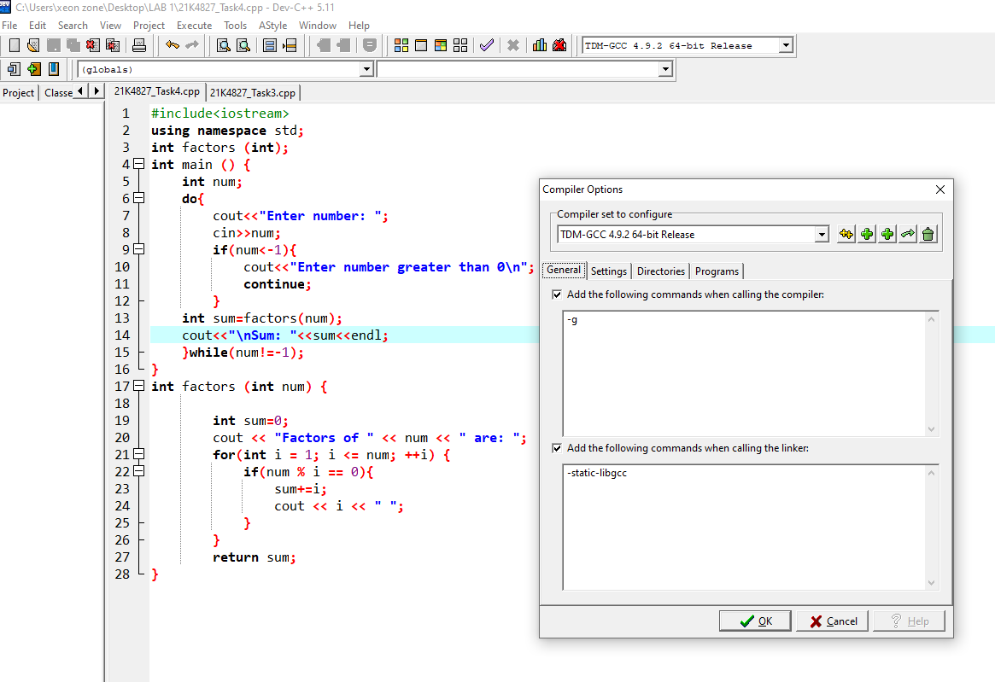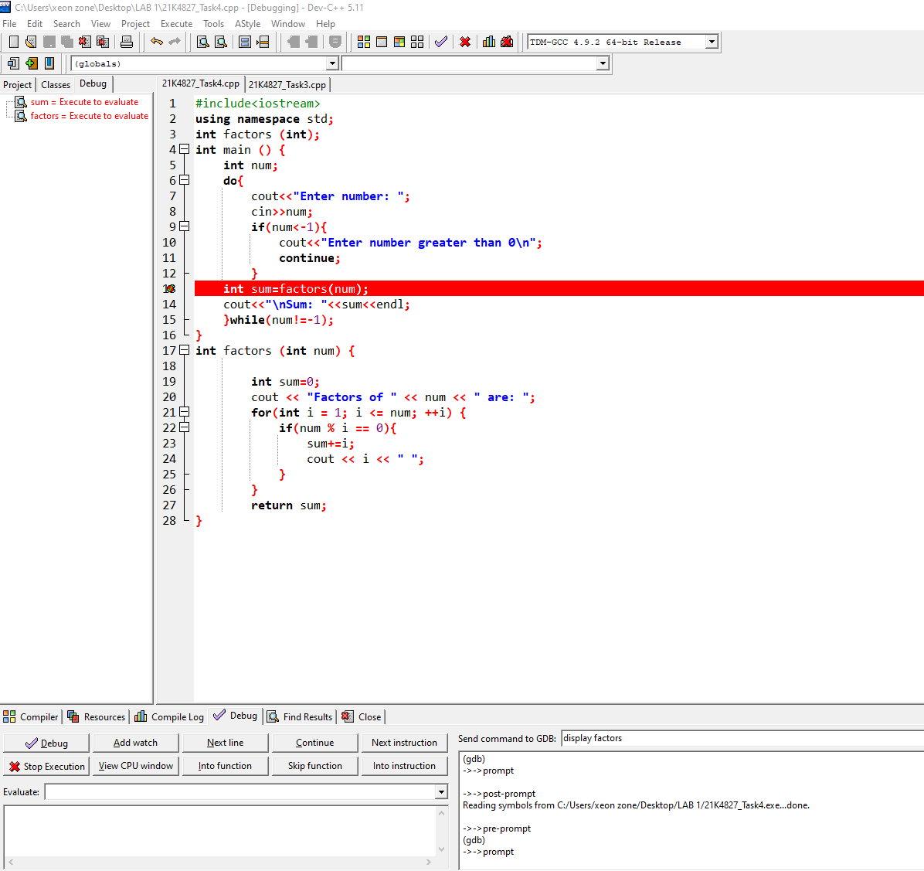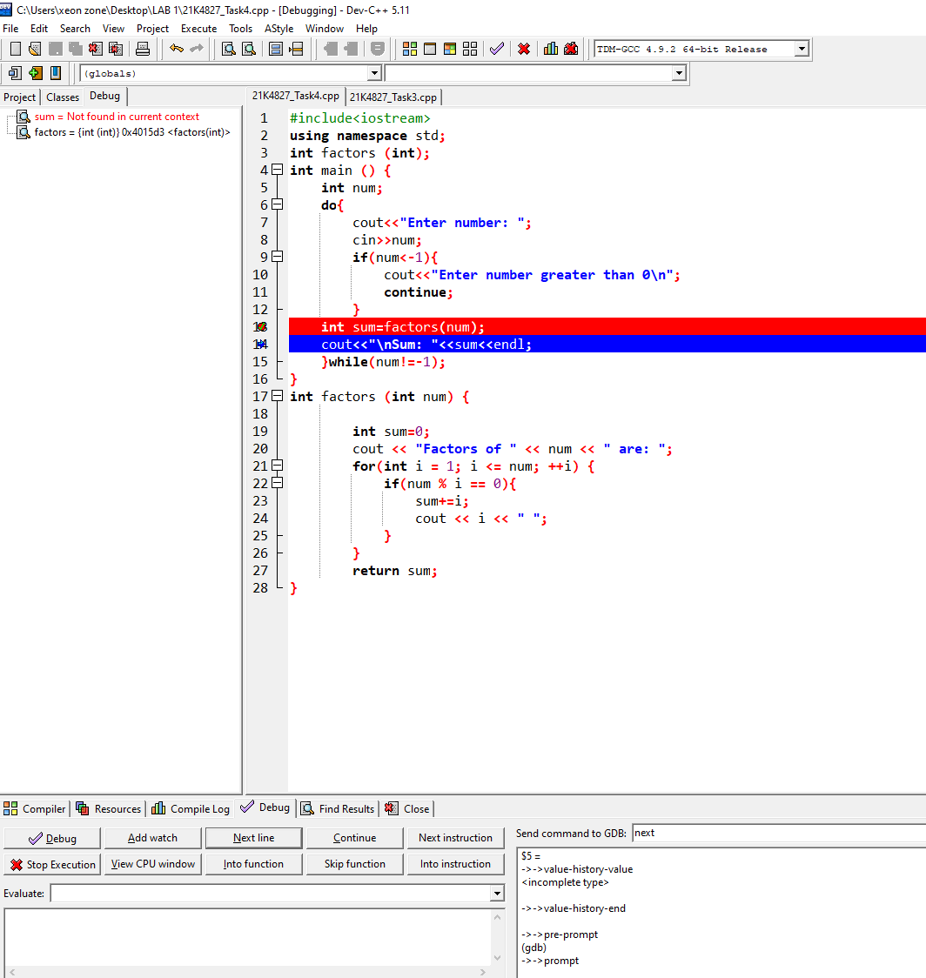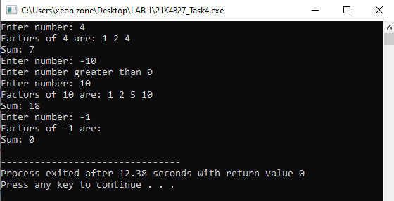

Q.5)

#include<iostream>

using namespace std;

void minmax(int\* , int \*,int \*,int);

int main(){

int num;

cout<<"Enter array size:";

cin>>num;

int min=1000;

int max;

int arr[num];

for(int i=0;i<num;i++){

cout<<"Enter value ["<<i<<"]:";

cin>>arr[i];

}

minmax(arr,&min,&max,num);

cout<<"Ther largest value is "<<max<<endl;

cout<<"The smallest value is "<<min<<endl;

}

void minmax(int ar[], int \*p,int \*q,int n){

for(int i=0;i<n;i++){

if(ar[i]<\*p){

\*p=ar[i];

}

if(ar[i]>\*q){

\*q=ar[i];

}

}

}

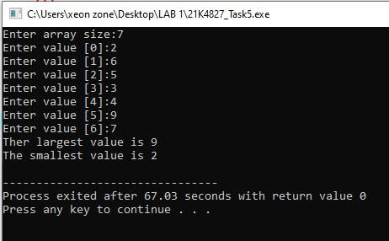

Q.6)

#include<iostream>

using namespace std;

int main(){

int s;

cout<<"How many sections grades you want to store?";

cin>>s;

char \*\*arr = new char\*[s];

int Size[s];

int i,j;

for(i=0;i<s;i++){

cout<<"Section "<<i+1<< " number of students: ";

cin>>Size[i];

arr[i] =new char[Size[i]];

}

for(i=0;i<s;i++){

for(j=0;j<Size[i];j++){

cout<<"Enter Section " <<i+1<<" grades: ";

cin>>\*(\*(arr + i) + j);

}

}

}

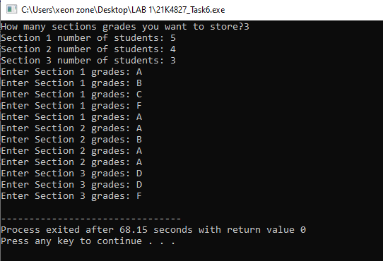

Q.7)

#include <iostream>

using namespace std;

class car{

string color;

int model;

int \*p;

public:

car(string c , int m){

color= c;

p= new int;

model =m;

}

void setc(string c){

color = c;

}

void setm(int m){

model = m;

}

void setp(int p1){

\*p = p1;

}

void print(){

cout << \*p << endl;

cout << color << endl;

cout << model << endl;

}

car( car &c1){

p = new int;

color=c1.color;

model= c1.model;

\*p = \*(c1.p);

}

~car(){

delete p;

cout<<"Delete operation performed"<<endl;

}

};

int main(){

car c1("red" , 1234);

car c2(c1);

car c3=c1;

c1.setp(1);

c2.setp(2);

c3.setp(3);

c1.print();

c2.print();

c3.print();

}

